IntroductiontoPacketTracer

LabObjectives
  - CiscoPacketTracer5.1Overview
  - CreatingDevices
  - AddingModules
  - MakingConnections
  - CreatingNetworks

LabContent

CiscoPacketTracer5.1 Overview

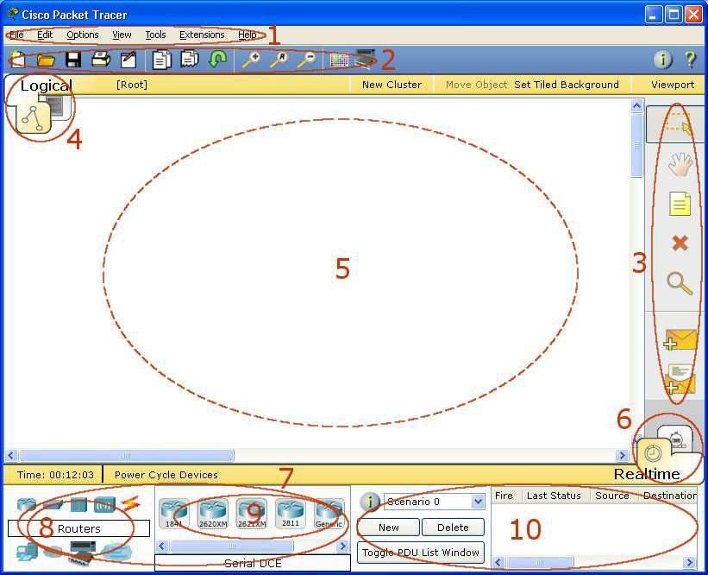

1 | MenuBar | This bar provides the File, Edit, Options, View, Tools, Extensions,andHelpmenus.Youwillfindbasiccommandssuch as Open, Save, Print, and Preferences in these menus. You will also be able to access the Activity Wizard from the Extensions  menu.
2 | Main Tool Bar | This bar provides shortcut icons to the File and Edit menu commands.ThisbaralsoprovidesbuttonsforZoom,thedrawing Palette, and the Device Template Manager. On the right, you will also find the Network Information button, which you can use to entera description for the current network (or anytext you  wish to include).
3 | CommonTools Bar | Thisbarprovidesaccesstothesecommonlyusedworkspacetools: Select, Move Layout, Place Note, Delete, Inspect, Add Simple PDU, and Add Complex PDU. See "Workspace Basics"for more  information.
4 | Logical/Physical Workspace and Navigation Bar | You can toggle between the Physical Workspace and the Logical Workspace with the tabs on this bar. In Logical Workspace, this baralsoallowsyoutonavigatethroughlevelsofacluster,createa new New Cluster, Move Object, Set Tiled Background, and Viewport. InPhysicalWorkspace,thisbarallows youtonavigate through physical locations, create a New City, create a New Building, create a New Closet, Move Object, apply Grid to the background, Set Background, and go to the Working Closet.
5 | Workspace | Thisareaiswhere youwillcreateyournetwork,watch  simulations,and viewmanykinds ofinformation and statistics.
6 | Realtime/Simul ation Bar | You can toggle between Realtime Mode and Simulation Mode with thetabs on this bar. This baralso provides buttons to Power CycleDevicesaswellasthePlayControlbuttonsandtheEvent List toggle button in Simulation Mode. Also, it contains a clock  thatdisplaystherelativeTimeinRealtimeMode andSimulationmode.
7 | Network ComponentBox | This box is where you choose devices and connections to put into theworkspace.ItcontainstheDevice-TypeSelectionBoxandthe  Device-SpecificSelectionBox.
8 | Device-Type Selection | This box contains the type of devices and connections available in PacketTracer5.1.TheDevice-SpecificSelectionBoxwillchange  dependingonwhichtype ofdeviceyouchoose.
9 | BoxDevice-Specific Selection Box | Thisboxiswhereyouchoosespecificallywhichdevicesyou want  toputin yournetwork andwhichconnections tomake.
10 | UserCreated Packet  Window* | This window manages the packets you put in the network during simulationscenarios.Seethe"SimulationMode"sectionformore  details.

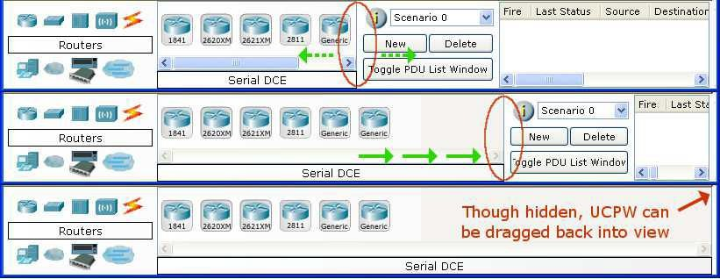

  - CreatingDevices
    - Chooseadevicetypefrom theDevice-TypeSelectionbox

    - Clickon thedesired devicemodel from theDevice-SpecificSelectionbox.

    - Clickonalocationintheworkspacetoputyour deviceinthat location.

    - Ifyouwanttocancelyourselection,presstheCanceliconforthatdevice.

    - Alternatively,youcanclickanddragadevicefromtheDevice-SpecificSelectionboxontothe workspace.

    - Youcan also click and dragadevice directlyfrom the Device-TypeSelection box and adefault device model will be chosen.
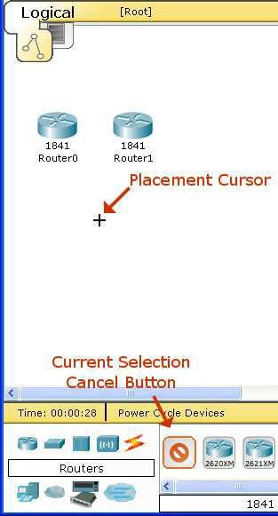

AddingModules
- Clickon adeviceto bringupits configurationwindow.

- Bydefault,youwillbeinthePhysicalDevice Viewsubpanelofthedevice.

- You can browse (by clicking) through the list of modules and read their description in the information box at the bottom.

- When you have found the module you want to add, simply drag it from the list into a compatible bayon the device picture.

- Youcanremoveamodulebydraggingit fromthedeviceback into the list.

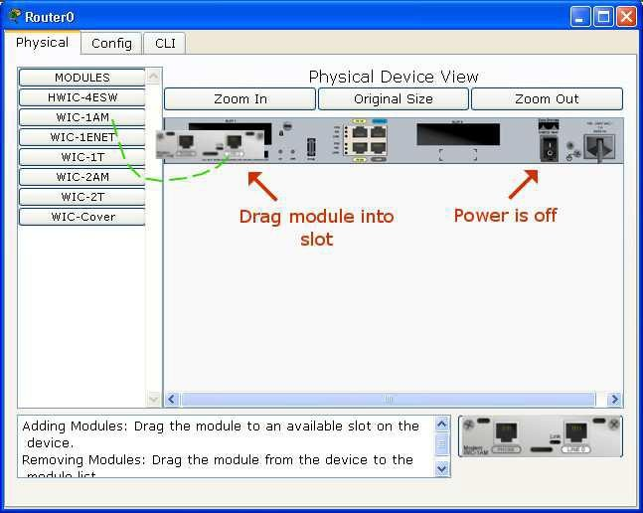

MakingConnections
- To make a connection between two devices,firstclick theConnectionsicon fromtheDevice-Type Selection box to bring up the list of available connections.

- Thenclicktheappropriatecabletype.

- Themousepointerwill changeintoa"connection" cursor.

- Clickon thefirst deviceand choose an appropriateinterfacetowhich toconnect.

- Thenclick on thesecond deviceanddo thesame.

- A connection cable will appear between the two devices, along with link lights showing the link status on each end (for interfaces that have link lights).

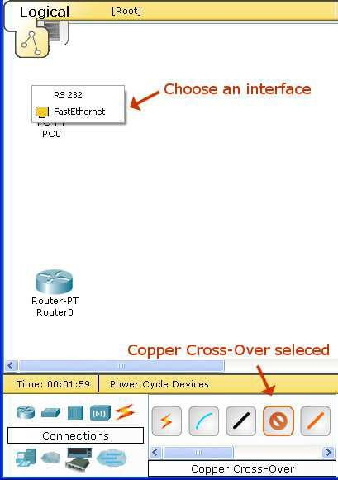

CreatingNetworks
  - Start creating a network by first selecting the End Devices. Add a Generic PC and a Generic Server to the workspace.

  - UnderConnections,selecttheCopperStraight-through cable (solidblack line)and connectthedevices with it. The red lights on the link indicate that the connection is not working. Now, use the Delete tool to remove the Copper Straight-through cable, and use a Copper Cross-over cable (dashed line) instead. The lights should turngreen at this point, and ifthemousepointeris held overeither thePC ortheServer,the link status will be shown as “Up.” The network should look similar to the picture below.

  - Click on the PC. While paying attention to the link lights, turn the power on, off, and on again. Follow the same steps for the server. The link lights turn red when the device is off. This means that the link is down or is not working. The link lights turn green when the device is turned back on.

  - Try all three ways to learn about the devices. First, mouse over the devices to see basic configuration information about them. Second, click on each device with the Select tool to show the device configuration window, which provides several ways to configure the device. Third, use the Inspect tool toviewtables thenetworkdevice willbuildas itlearnsaboutthenetwork aroundit. In thisexample,only the ARP tables will appear. Since the devices have not been configured yet, the ARP tables are empty. Always remember to close windows after viewing them or they will clutter the workspace.
  - Open the PC configuration window and change the settings using the Config tab. Change the display name to Client and set the DNS server to 192.168.0.105. Under Interface, click FastEthernet and set the IP address as 192.168.0.110. Packet Tracer automatically calculates other parameters. Make sure that the Port Status box is checked. For future reference, note that other Ethernet interface settings, such as bandwidth, duplex, MAC address, and subnet mask can be modified using this window.

  - GototheDesktopTabandclickon IPConfiguration.NoticethattheIPaddress, subnetmaskandDNS server can be changed here as well.

  - Open the Server configuration window and go to the Config tab. Change the display name to Web Server. Click FastEthernet and set the IP address as 192.168.0.105. Make sure that the Port Status is also on. Click DNS and set the domain name as www.firstlab.com. Set the IP address as 192.168.0.105 and click Add. Finally, check to make sure that the service for DNS is on.

  - Reposition the network devices by dragging them to a new location. Add a network description by using the “i” button on the upper right corner. Then add some text labels within the Logical Workspaceby using the Place Note tool.

  - LoadabackgroundgridusingtheSetTiledBackground button.

  - Saveyourwork usingtheFile>SaveAsoptionandcreateameaningful filename.

